lap 1

بارعة الربيش - 411202024

**Task 2: Filter HTTP packets and analyze them.**

step 3: Step 3: Observe the HTTP

method: Get

[Full request URI […]: <http://1d.tlu.dl.delivery.mp.microsoft.com/filestreamingservice/files/92a38541-6484-48bd-8e7b-1a53491fb831?P1=1725659956&P2=404&P3=2&P4=RCCakqcQC7yHyy3zV75A35hMKR8nNrmrrBm0kXx6bYZd5MRv5KiuRwkk8Wrz6Z%2fG9dvyW%2fkPP5B> ]

response code: 206 partial content

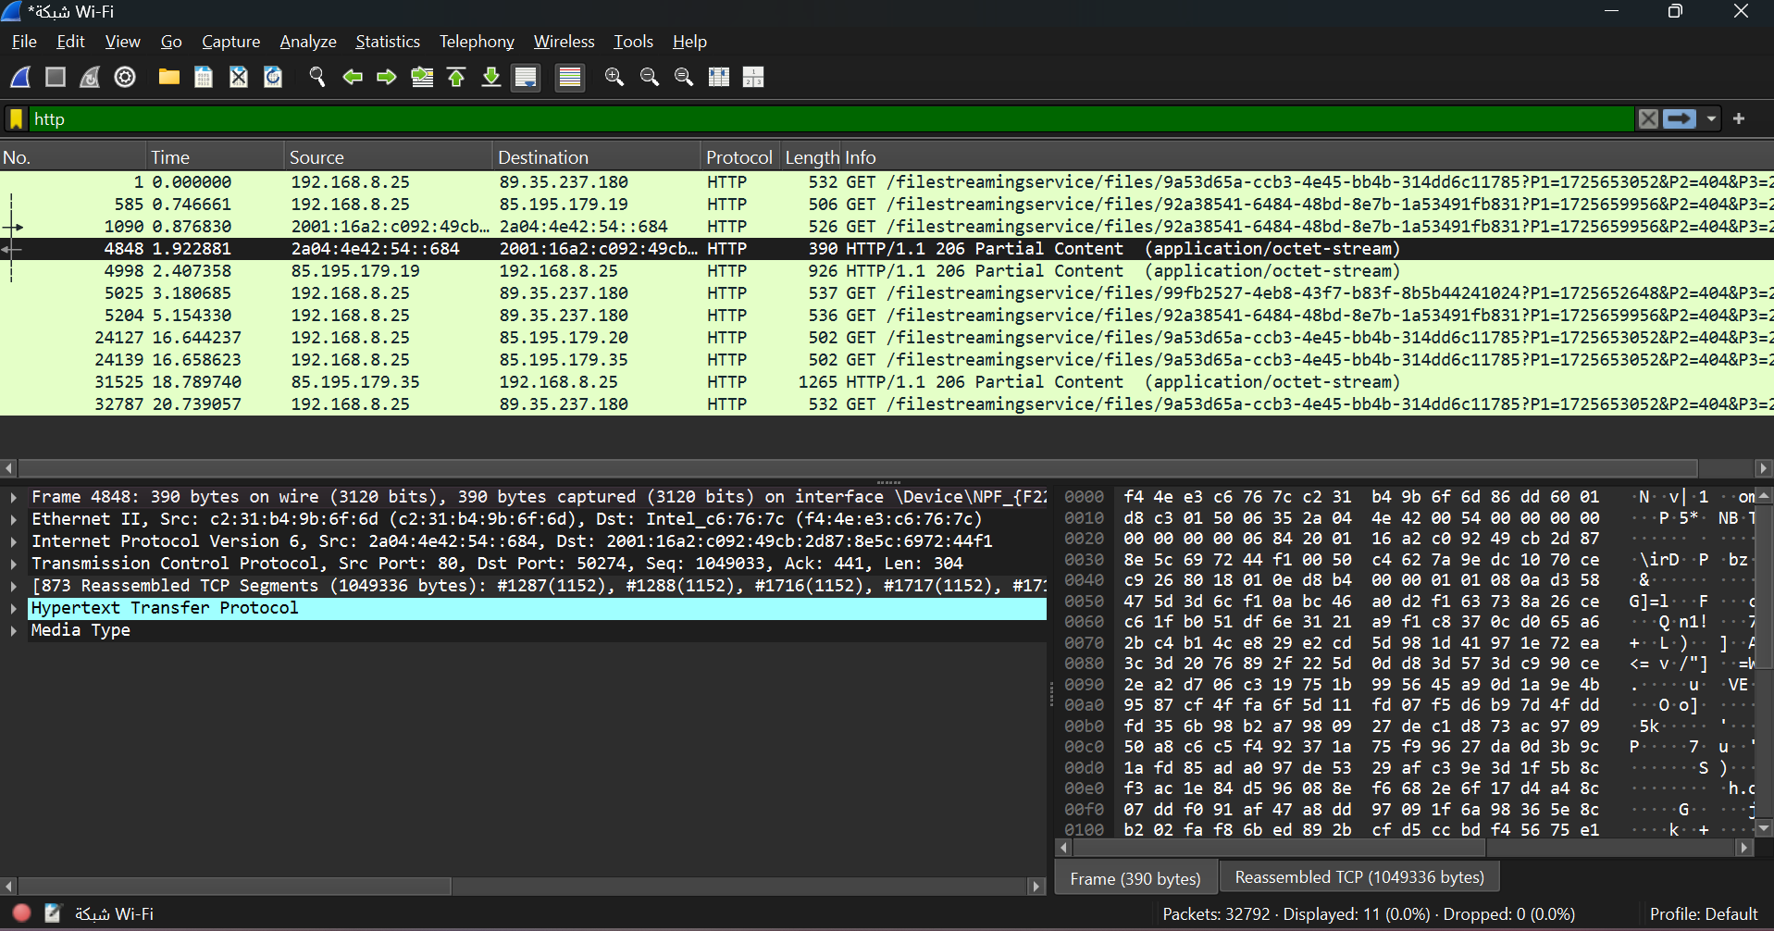

**Part 2: Analyzing TCP/IP Traffic.**

Step 4: This shows the entire conversation between the client and server.

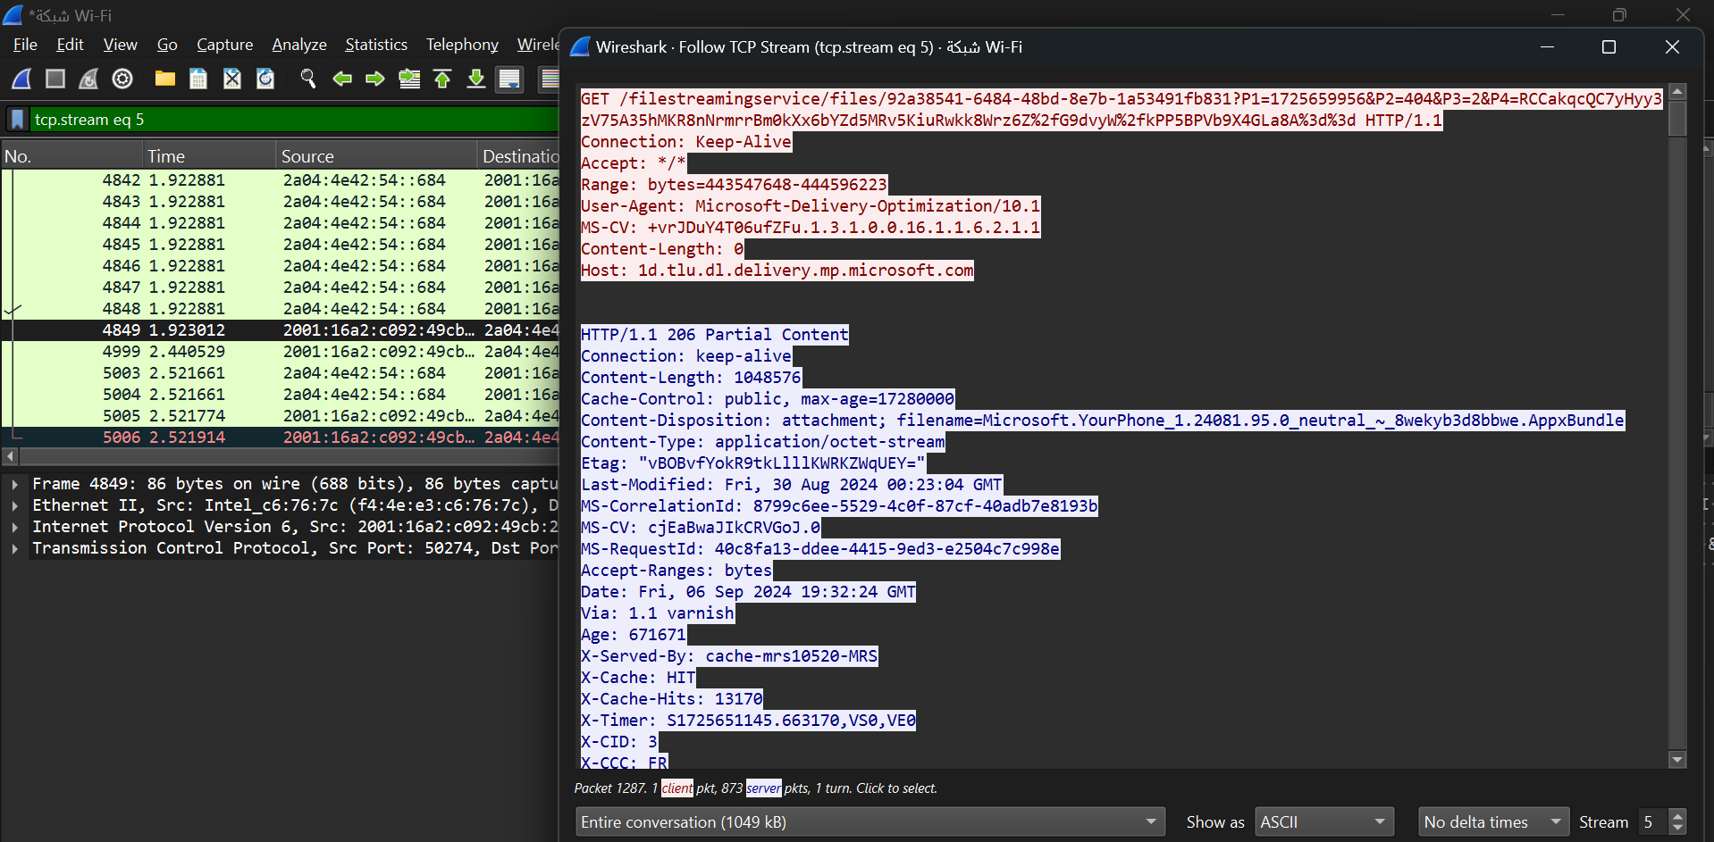

**Task 2: Analyze TCP handshake and investigate Data Transfer and Termination**

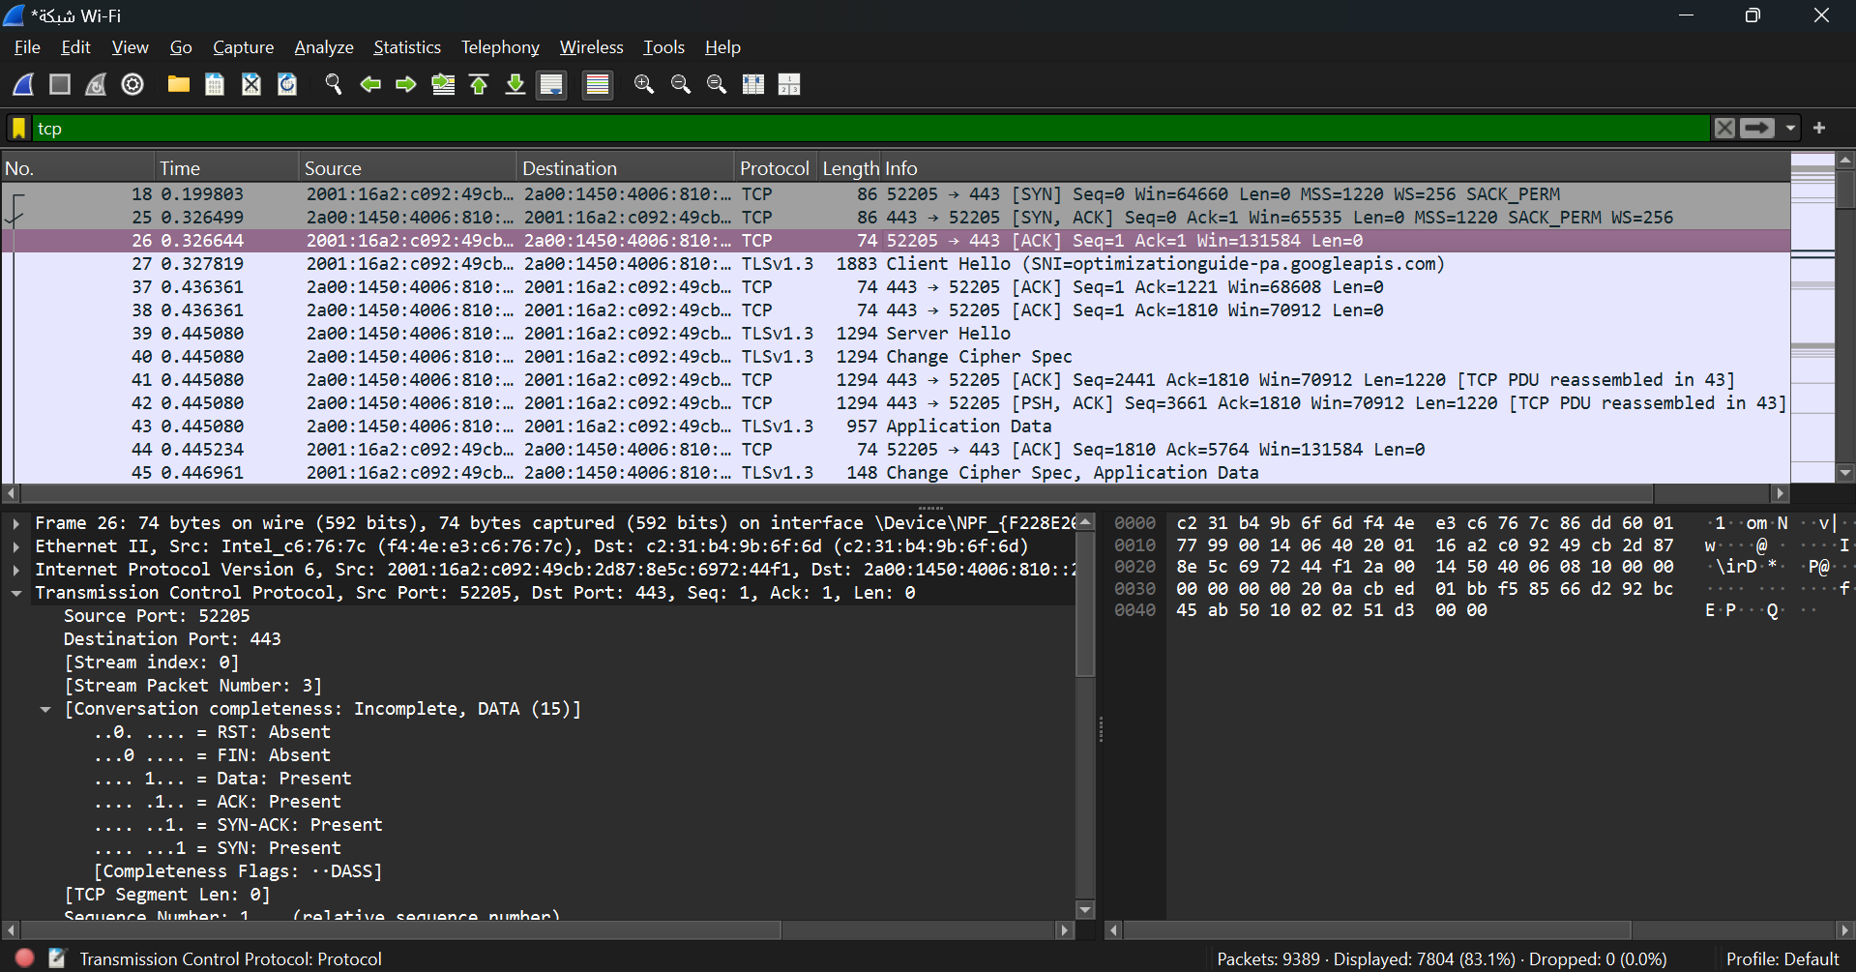

**part 3: capturing and analyzing UDP traffic**

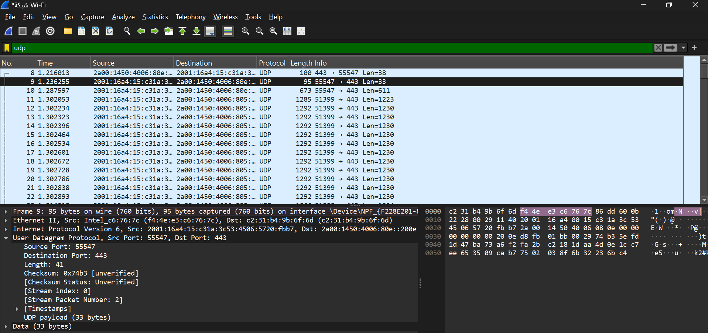

**Part 4: Comparing TCP and UDP by filling in the following tables.**

|  | **TCP or UDP** | **Reasons** |
| --- | --- | --- |
| **Reliability and Connection Establishment** | TCP | TCP ensures reliable delivery by establishing a connection and retransmitting lost packets, making it ideal for critical applications. |
| **Data Integrity and Ordering** | TCP | TCP guarantees data integrity and correct ordering through sequencing and error checks, suitable for precise data handling. |

|  | **Use Cases** | **Performance** |
| --- | --- | --- |
| **TCP** | Web Browsing (HTTP/HTTPS)  Email (SMTP, IMAP)  File Transfers (FTP, SFTP)  Remote Access (SSH, Telnet) | Slower  Reliable |
| **UDP** | Video Streaming (YouTube, Netflix) Online Gaming  Voice Calls (VoIP) | Faster  Unreliable |